Opening Day Round-ups:
Season 2019/20
#1
Premier Division: Plymouth Parkway made a storming start to the season at Bolitho Park, with Adam Carter’s four first half goals propelling them to a 7-1 victory over Cadbury Heath. Carter took less than 60 seconds to open his account for the campaign, before adding two more in the space of 18 minutes to register a quick-fire treble. The frontman then added a fourth toward the end of the first half, with goals after the interval from Teigan Rosenquest, Jack Calver and Ryan Lane completing the win. Another man to complete an opening day hat-trick, was Bitton’s Josh Egan. The Somerset side shot out of the blocks during their 5-1 triumph away at Hallen, with Egan scoring twice, adding to goals from Scott Brice and Harrison Kyte during a four-goal opening quarter. Isaac Reid gave the home crowd something to cheer late on, before Egan scored his third of the contest in the closing stages. It was a fruitful afternoon for many other away sides in the Premier Division, with Westbury coming from behind to defeat Buckland Athletic 3-1 at Homers Heath. A fine volley from Conor Bryant gave the hosts a 19th minute lead, before Jason Henley levelled things up for United on the half-hour mark. With 15 minutes left on the clock, Ricky Hulbert finished from close range following a long-throw from brother Steve, with Hulbert then doubling his tally five minutes from time to wrap up all three points. Tavistock made a winning start to life in the Western League, overturning a half-time deficit on their way to a 2-1 victory away at Clevedon. The hosts made the perfect start, going ahead inside three minutes thanks to a Lucas Vowles header, only for Tavistock to draw level thanks to a special strike from Luke Brown in the opening passage of the second half. With the game headed towards a draw, Dan Evans nodded home a set-piece in the final 20 minutes to hand the Lambs victory. Exmouth also enjoyed opening day success following their promotion, with a double from Jordan Harris, plus a pair of own goals leading them to a 4-1 defeat of Bridport.
Tavistock claimed a 2-1 victory away at Clevedon Town. Image courtesy of John Pool.

Another side to score four in victory were Bradford Town, with a strong first half showing proving just enough for them to see off First Division champions Keynsham Town. Following a quiet start to the contest, the home side came to life in the lead-up to half-time, with Lewis Ellington, Matty Morris and Neikell Plummer all scoring during a dominant 15-minute period. The K’s outscored their hosts by two goals to one after the interval, with Gary Higdon putting the result beyond doubt in the closing stages. Brislington turned many of the pre-season predictions on their head, securing a 2-1 victory at home to Bridgwater Town. Jayden Nielson handed the home side the best possible start, giving them a fifth minute lead, only for Bridgwater to level proceedings ten minutes before the break through Jamie Laird. The third and final goal of the game proved to be vital, with Oaklan Buck heading home in first half stoppage time to hand Brislington all three points. Shepton Mallet held off a spirited fightback from Street to claim a 3-2 victory in the Mendip’s. After Jack Fillingham had handed them a first half lead, Mallet soon stretched their advantage to three thanks to Aaron Seviour and Joe Morgan. The young Cobblers made a spirited fightback in the final half hour, falling just short of a dramatic comeback despite two goals in quick succession from Kyle Strange and Brad Shephard. Odd Down took all three points back to Bath with them, after first half goals from Reeko Best and Jay Murray helped them defeat Roman Glass St George 2-1. Chipping Sodbury Town were also 2-1 victors despite being down to ten men, with goals either side of half-time from Sam Makepeace and Nathan Brown helping them beat Cribbs.
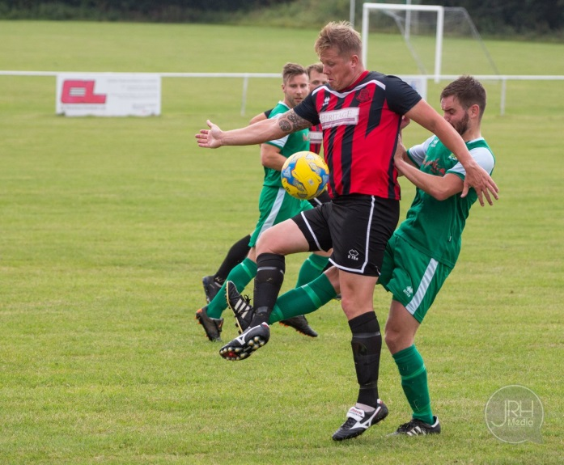
First Division: Bishops Lydeard laid down an early marker, scoring at will during their 7-0 triumph away at Hengrove Athletic. Lydeard were among the highest scorers in the division last season despite their 12th placed finish, and they took little time in going ahead at Paprika Park, with George Painter heading home in the 10th minute. Ben Hebditch took advantage of some poor defensive work to score either side of the interval, before Charlie Wilson made it 4-0 as the game reached the hour mark. The visitors maintained their attacking intent during the contest, with substitute Will Hazeldine and Ryan Brereton each getting on the scoresheet, before Hebditch completed his hat-trick with the final kick of the game. The crowd at Bowdens Park also witnessed also witnessed an opening day hat-trick, with Adam Wright picking up where he left off last season, scoring all of Cheddar’s goals during their 3-2 triumph over Devizes. Having fallen behind to Joe Broadbank’s opener, the hosts got back on level terms when Wright converted a spot kick midway through the first half.
Bishops Lydeard stormed to a 7-0 victory over Hengrove. Image courtesy of James Healey.
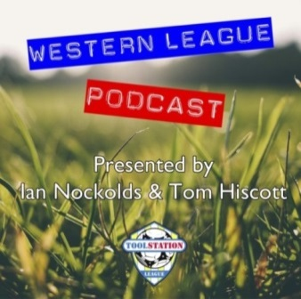
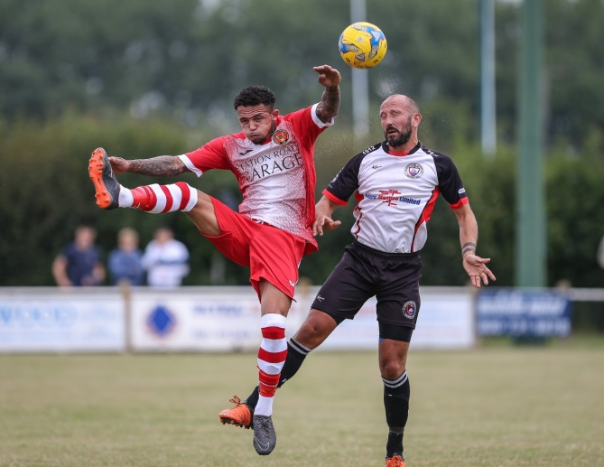
Another successful penalty three minutes after the interval saw Wright hand Cheddar their first lead, which was doubled 20 minutes from time when Wright struck for the third time. Devizes were awarded a penalty of their own in the final minutes, but despite finding the back of the net, they were unable to grab a share of the spoils. A four-goal blitz during the first half from Wells City saw them secure a 4-2 victory away at Sherborne Town. The home side had taken an early lead through Ashley Clarke, before a quick-fire double from Harry Foster and Craig Herrod turned the game in Wells’ favour. Foster and Dale Hunt then struck in the space of ten minutes to extend the lead to three, meaning George Mapletoft’s second half effort proved to be in vain for the defeated Sherborne. Lebeq United showed excellent resolve, coming from a goal down to win 3-1 at Bishop Sutton in their Western League debut. Following a goalless opening half, Shah Bhakerd produced two excellent finishes, before Rick Davis completing the scoring in Lebeq’s come-from-behind victory. There was late drama at Stockwood Lane, where young substitute Owen McCallum scored the vital goal for Oldland in their 1-0 win over Bristol Telephones, while a goal in either half from Stuart Windsor helped Calne defeat Radstock 2-0. A strong defensive showing from Welton Rovers saw them claim victory in their opening fixture, with Lewis Coleman scoring the only goal of the game during their 1-0 win away at Warminster. A stunning long range effort from Lewis McCarron proved to be the difference at the Southbank Ground, where Corsham secured a 2-1 win over Portishead Town. After Josh Bright had slotted the home side ahead in the 20th minute, Corsham doubled their lead five minutes later with an early goal of the season contender from McCarron who arrowed home an unstoppable strike from 40 yards. Portishead got a lifeline just before the interval, but were unable to get level during a goalless second half to hand Corsham all three points. Longwell Green Sports grabbed an impressive 2-0 win away at Almondsbury, while Toby Dolton Cole rescued a point for Wincanton during their 1-1 draw at home to Ashton & Backwell United.
Action from Corsham’s 2-1 victory over Portishead, courtesy of John Cuthbertson.

Ian, Tom & guests will return for a third season of the podcast, recapping all the latest news and results from around the Western League. Be sure to follow along all season, with each broadcast available at the following link: http://www.toolstationleague.com/podcasts.php

Toolstation Charity Cup Report

Bitton 3 Bridlington Town 2
Saturday 26th July 2019
More images, courtesy of James Healey, are available at the following link: http://www.toolstationleague.com/gallery/tscup/

Bitton staged a remarkable recovery from being 2-0 down in three minutes to set up a last gasp winner and take the Toolstation Charity Cup at a sunny Fairfax Park, Bridgwater on Saturday afternoon writes Kerry Miller.
A Matt Groves strike seconds from the end sent Yorkshire side Bridlington Town home empty handed after an excellent match, which was a credit to both the Western and the Northern Counties East Leagues.
Bridlington arrived at Fairfax Park having ended last season in third place behind champions Worksop Town and Penistone Church, who won the cup last year, and it soon became obvious why as Matt Broadley slung in an inch perfect cross for Joe McFadyen to volley past Bitton keeper Sam Burgess via a slight deflection with a minute on the clock. With their next attack the square defence was rooted as McFadyen latched onto a through ball and lobbed Burgess from 25 yards out to make it 2-0 inside three minutes and when seconds later McFadyen was free in the box with the defence struggling, only a last ditch tackle robbed the striker of one of the quickest ever hat-tricks.
Remarkably for the visitors, who made the journey down that morning, that was as good as it got, for Dan Langdon’s men regrouped and began to claim a toe hold on the game and five minutes later the lead was halved as Alex Grimshaw found room on the left and Groves nodded home his cross. Happily for the supporters this was anything but a pre-season friendly stroll and with Dean Griffiths’ strength causing problems up front and some incisive passing football from both sides more goals were on the cards. Burgess tipped over a free-kick on the half hour and Griffiths had a drive well saved by James Hitchcock then Groves’ superb first touch allowed him to set up Josh Egan but he volleyed over from 12 yards.
Just on half-time Bitton levelled when Groves’ curled in a corner which somehow ended up in the net via a defender’s head and from a seemingly disastrous opening Bitton were playing some great stuff and were right back in the game.
Right from the restart Bitton went at Bridlington and Griffiths had another drive saved by Hitchcock before the Yorkshiremen showed they were still in their pitching as Ben Lewis was just wide with a left foot drive. Bitton substitute Mitch Tipping then had an effort of his own held before Egan hit the bar with a shot and with both sides going for the win and penalties looming Fraser Papprill was close with a free-kick for Town. McFadyen was inches away from a match-winning hat-trick five minutes from time but it wasn’t to be and soon after Groves drove in the winner to make sure the Toolstation Cup resides in Bristol for the next 12 months as Bitton prepared in style for another tilt at the Western League title.

Latest Results
Saturday 3rd August 2019
Premier Division
Bradford Town 4-2 Keynsham Town 141
Brislington 2-1 Bridgwater Town 122
Buckland Athletic 1-3 Westbury United 107
Clevedon Town 1-2 Tavistock 87
Cribbs 1-2 Chipping Sodbury Town 115
Exmouth Town 4-1 Bridport 202
Hallen 1-5 Bitton 70
Plymouth Parkway 7-1 Cadbury Heath 303
Roman Glass St George 1-2 Odd Down 85
Shepton Mallet 3-2 Street 202
First Division
Almondsbury 0-2 Longwell Green Sports 54
Bishop Sutton 1-3 Lebeq United 66
Bristol Telephones 0-1 Oldland Abbotonians 41
Calne Town 2-0 Radstock Town 105
Cheddar 3-2 Devizes Town 73
Corsham Town 2-1 Portishead Town 109
Hengrove Athletic 0-7 Bishops Lydeard 52
Sherborne Town 2-4 Wells City 112
Warminster Town 0-1 Welton Rovers 174
Wincanton Town 1-1 Ashton & Backwell United 45
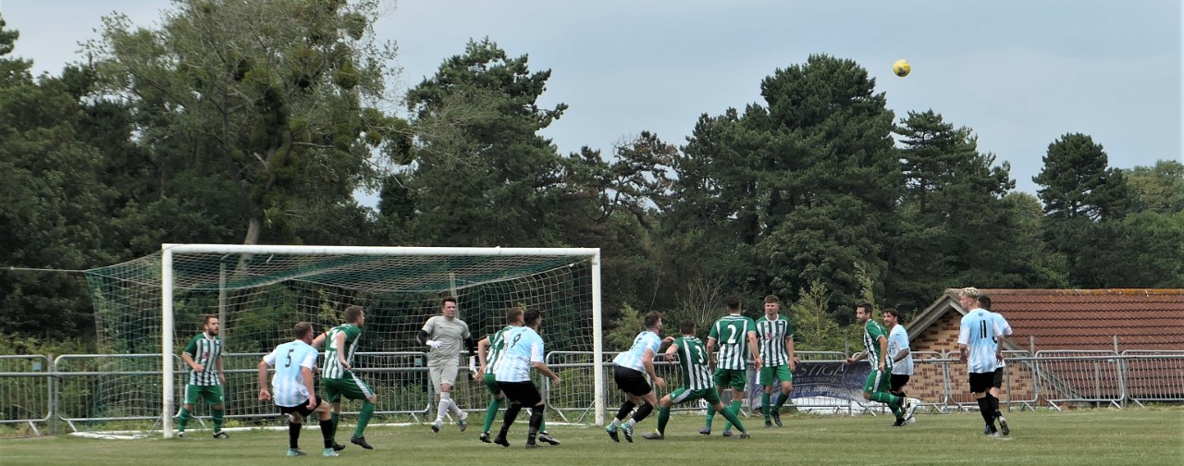
Action from Longwell Green’s 2-0 victory over Almondsbury, courtesy of Andy Radford.
Midweek Fixtures
Tuesday 6th August 2019
Premier Division
Bitton vs Chipping Sodbury Town 19:30KO
Bridgwater Town vs Cribbs 19:45KO
Keynsham Town vs Wellington 19:45KO
Wednesday 7th August 2019
Premier Division
Westbury United vs Odd Down 19:30KO
Weekend Fixtures
Friday 9th August 2019
FA Cup – Extra Preliminary Round
Plymouth Parkway vs Buckland Athletic 19:45KO
First Division
Oldland Abbotonians vs Wells City 19:45KO
Saturday 10th August 2019 (KICK OFF AT 3.00PM UNLESS NOTED)
FA Cup – Extra Preliminary Round
Bitton vs Bridport
Bridgwater Town vs Hallen
Cheddar vs Bradford Town
Dunstable Town vs Chipping Sodbury Town
Exmouth Town vs Barnstaple Town
Keynsham Town vs Brislington
Saltash United vs Clevedon Town
Shepton Mallet vs Cadbury Heath
Street vs Odd Down 14:00KO
Tavistock vs Hengrove Athletic
Wellington vs Cribbs
Westbury United vs Fareham Town
First Division
Ashton & Backwell United vs Almondsbury
Bishops Lydeard vs Wincanton Town
Devizes Town vs Warminster Town
Lebeq United vs Calne Town 15:15KO
Longwell Green Sports vs Sherborne Town
Portishead Town vs Bristol Telephones
Radstock Town vs Corsham Town
Welton Rovers vs Bishop Sutton
Sunday 11th August 2019
FA Cup – Extra Preliminary Round
Winslow United vs Roman Glass St George 14:00KO
